Decagonal Cupola

Definition
# Source: AI Source: Provided by: [Data Path: Persons Table -> ID Column: 1, Name_En Column: Motasem Essam] -> From: [ChatGPT] on [7/25/2026]
A Decagonal Cupola is a cupola-shaped polyhedron consisting of a regular decagonal upper base (10 sides) and a regular icosagonal lower base (20 sides).
The two parallel bases are connected by an alternating arrangement of 10 triangular faces and 10 rectangular faces.
It belongs to the family of $n$-gonal cupolas, where $n=10$.
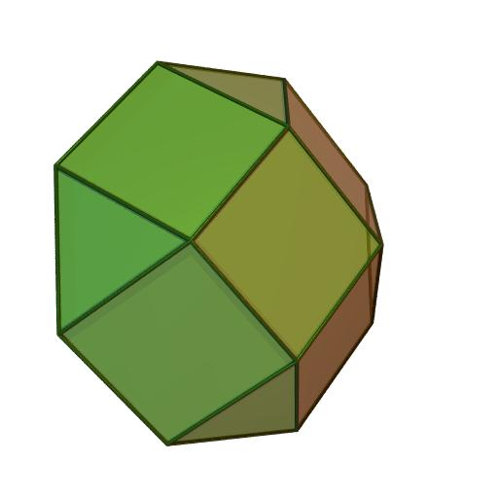

Simple Definition
# Source: AI Source: Provided by: [Data Path: Persons Table -> ID Column: 1, Name_En Column: Motasem Essam] -> From: [ChatGPT] on [7/25/2026]
A Decagonal Cupola is a solid with:
- One decagonal upper base (10 sides).
- One icosagonal lower base (20 sides).
- 10 triangular lateral faces.
- 10 rectangular lateral faces.
- 22 faces in total.
- 50 edges.
- 30 vertices.

Geometric Structure
# Source: AI Source: Provided by: [Data Path: Persons Table -> ID Column: 1, Name_En Column: Motasem Essam] -> From: [ChatGPT] on [7/25/2026]
The Decagonal Cupola consists of two parallel polygonal bases:
- Upper Base: A regular decagon with 10 sides.
- Lower Base: A regular icosagon with 20 sides.
- Central Axis: Passes through the centers of both bases and is perpendicular to their planes.
- Lateral Surface: Connects the two bases through alternating triangular and rectangular faces.
The 10 upper vertices correspond to alternating positions among the 20 lower vertices. This creates the characteristic cupola arrangement.
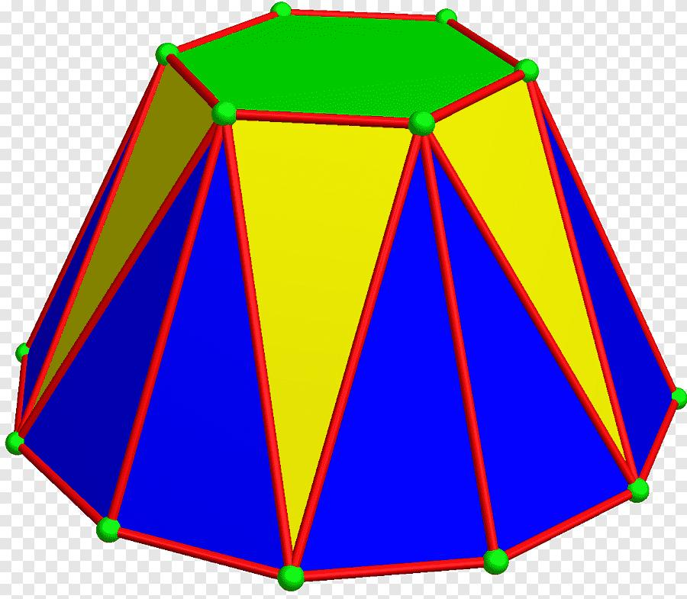

Face Structure
# Source: AI Source: Provided by: [Data Path: Persons Table -> ID Column: 1, Name_En Column: Motasem Essam] -> From: [ChatGPT] on [7/25/2026]
A Decagonal Cupola has 22 faces in total.
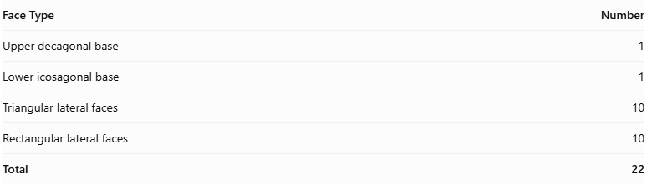
Face Type | Number
Upper decagonal base | 1
Lower icosagonal base | 1
Triangular lateral faces | 10
Rectangular lateral faces | 10
Total | 22
The lateral faces alternate around the solid:
- 10 triangular faces.
- 10 rectangular faces.
Important: The rectangular lateral faces are not necessarily squares. A regular-faced decagonal cupola, with all triangular faces equilateral and all rectangular faces square, is not possible. The regular-faced cupolas with these properties are the triangular, square, and pentagonal cupolas.
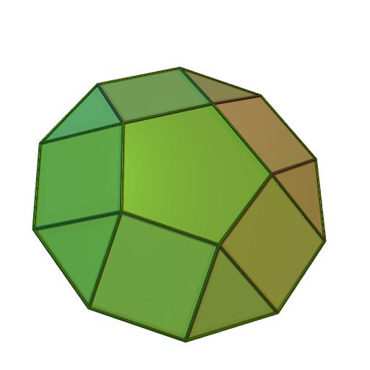

Edge Structure
# Source: AI Source: Provided by: [Data Path: Persons Table -> ID Column: 1, Name_En Column: Motasem Essam] -> From: [ChatGPT] on [7/25/2026]
A Decagonal Cupola has 50 edges.
The edges are divided into three groups:
- 10 edges around the upper decagonal base.
- 20 edges around the lower icosagonal base.
- 20 connecting edges between the two bases.
Therefore:
$$E=10+20+20$$
$$\boxed{E=50}$$
Each edge is shared by exactly two faces.

Vertex Structure
# Source: AI Source: Provided by: [Data Path: Persons Table -> ID Column: 1, Name_En Column: Motasem Essam] -> From: [ChatGPT] on [7/25/2026]
A Decagonal Cupola has 30 vertices:
- 10 vertices on the upper decagonal base.
- 20 vertices on the lower icosagonal base.
Each vertex is shared by exactly three faces in the standard cupola arrangement.
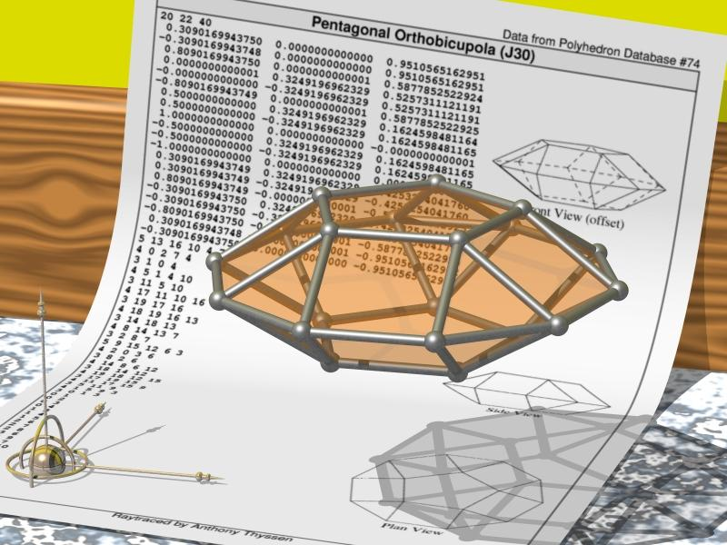

Mathematical Properties
# Source: AI Source: Provided by: [Data Path: Persons Table -> ID Column: 1, Name_En Column: Motasem Essam] -> From: [ChatGPT] on [7/25/2026]
For a general $n$-gonal cupola, the mathematical formulas are:
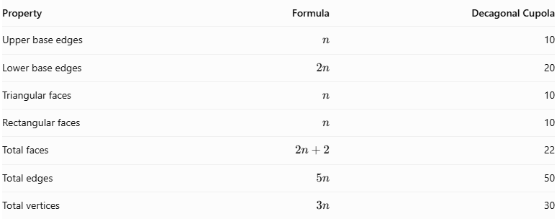
Property | Formula | Decagonal Cupola
Upper base edges | $$n$$ | 10
Lower base edges | $$2n$$ | 20
Triangular faces | $$n$$ | 10
Rectangular faces | $$n$$ | 10
Total faces | $$2n+2$$ | 22
Total edges | $$5n$$ | 50
Total vertices | $$3n$$ | 30
Euler's Formula
Every convex polyhedron satisfies:
$$V-E+F=2$$
Substituting:
$$30-50+22=2$$
$$\boxed{2=2}$$
Therefore, the Decagonal Cupola satisfies Euler's formula.

Face Incidence
# Source: AI Source: Provided by: [Data Path: Persons Table -> ID Column: 1, Name_En Column: Motasem Essam] -> From: [ChatGPT] on [7/25/2026]
Face incidence describes how faces meet at the vertices.
In a standard Decagonal Cupola:
- Each of the 10 upper vertices belongs to the upper decagon and three lateral faces.
- Each of the 20 lower vertices belongs to the lower icosagon and two lateral faces.
- Exactly 4 faces meet at every upper vertex.
- Exactly 3 faces meet at every lower vertex.
The vertex configurations are:
- Upper vertices: $3.4.10.4$
- Lower vertices: $3.4.20$
These configurations describe the arrangement of polygons surrounding each vertex.

Surface Area and Volume

Surface Area
# Source: AI Source: Provided by: [Data Path: Persons Table -> ID Column: 1, Name_En Column: Motasem Essam] -> From: [ChatGPT] on [7/25/2026]
The total surface area is the sum of the areas of both polygonal bases and all lateral faces.
$$S=A_{10}+A_{20}+10A_{t}+10A_{r}$$
Where:
- $A_{10}$ = Area of the upper regular decagon.
- $A_{20}$ = Area of the lower regular icosagon.
- $A_{t}$ = Area of one triangular lateral face.
- $A_{r}$ = Area of one rectangular lateral face.
For a regular polygon with $m$ sides of length $a$:
$$A=\frac{{ma}^{2}}{4tan(π/m)}$$
The total surface area depends on the actual dimensions of the cupola.

Volume
# Source: AI Source: Provided by: [Data Path: Persons Table -> ID Column: 1, Name_En Column: Motasem Essam] -> From: [ChatGPT] on [7/25/2026]
The Decagonal Cupola is a prismatoid. Its volume can be calculated using the prismatoid formula:
$$\boxed{V=\frac{h}{6}(A_{1}+4A_{m}+A_{2})}$$
Where:
- $h$ = Perpendicular distance between the base planes.
- $A_{1}$ = Area of the upper decagonal cross-section.
- $A_{2}$ = Area of the lower icosagonal base.
- $A_{m}$ = Area of the cross-section halfway between the bases.
A numerical volume requires the dimensions and relative positioning of the bases.

Symmetry
# Source: AI Source: Provided by: [Data Path: Persons Table -> ID Column: 1, Name_En Column: Motasem Essam] -> From: [ChatGPT] on [7/25/2026]
A standard symmetric Decagonal Cupola has the following symmetry properties:
- Rotational Symmetry: Tenfold rotational symmetry around its central axis.
- Vertical Reflection Symmetry: 10 vertical reflection planes passing through the central axis.
- Horizontal Reflection Symmetry: Not generally present because the upper and lower bases have different numbers of sides.
- Central Symmetry: Not generally present.
Its symmetry group is:
$$\boxed{C_{10v}}$$
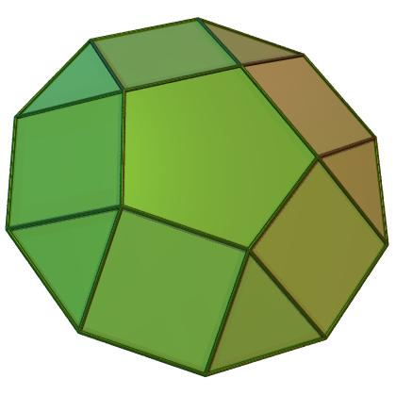

Relationship to Other Solids
# Source: AI Source: Provided by: [Data Path: Persons Table -> ID Column: 1, Name_En Column: Motasem Essam] -> From: [ChatGPT] on [7/25/2026]
The Decagonal Cupola belongs to the family of $n$-gonal cupolas.
It is related to:
- Triangular Cupola: A triangular upper base and a hexagonal lower base.
- Square Cupola: A square upper base and an octagonal lower base.
- Pentagonal Cupola: A pentagonal upper base and a decagonal lower base.
- Nonagonal Cupola: A nonagonal upper base and an octadecagonal lower base.
- N-gonal Cupola: The general family with an $n$-sided upper base and a $2n$-sided lower base.
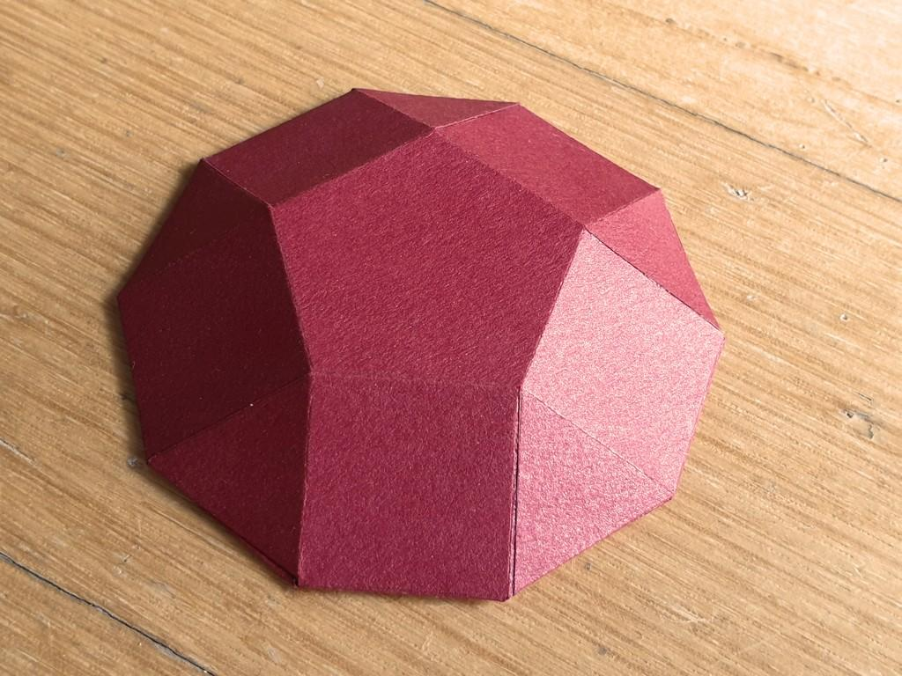
Pentagonal Cupola
5-sided upper base and 10-sided lower base.
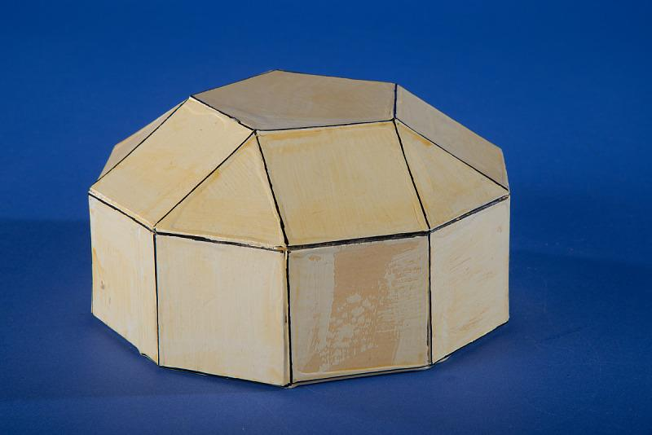
Decagonal Cupola
10-sided upper base and 20-sided lower base.
The cupola is also a type of prismatoid, because its two polygonal bases lie in parallel planes.

Worked Example
# Source: AI Source: Provided by: [Data Path: Persons Table -> ID Column: 1, Name_En Column: Motasem Essam] -> From: [ChatGPT] on [7/25/2026]
Problem: Find the number of faces, edges, and vertices of a Decagonal Cupola.
Solution:
Given:
$$n=10$$
Step 1: Calculate the number of faces.
$$F=2n+2$$
$$F=2(10)+2$$
$$\boxed{F=22}$$
Step 2: Calculate the number of edges.
$$E=5n$$
$$E=5(10)$$
$$\boxed{E=50}$$
Step 3: Calculate the number of vertices.
$$V=3n$$
$$V=3(10)$$
$$\boxed{V=30}$$
Final Answer:
- Faces = 22.
- Edges = 50.
- Vertices = 30.

Constructing Decagonal Cupola in Solid Geometry

Geometric Instruments Used
# Source: AI Source: Provided by: [Data Path: Persons Table -> ID Column: 1, Name_En Column: Motasem Essam] -> From: [ChatGPT] on [7/25/2026]
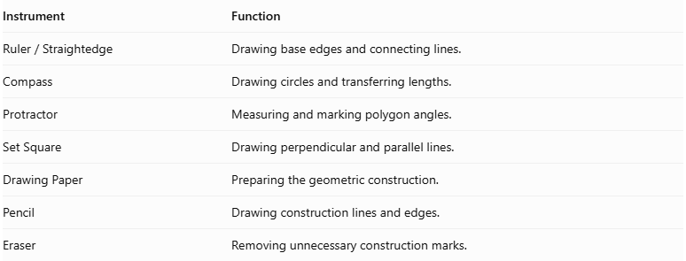
Instrument | Function
$$Ruler/Straightedge$$ | Drawing base edges and connecting lines.
Compass | Drawing circles and transferring lengths.
Protractor | Measuring and marking polygon angles.
Set Square | Drawing perpendicular and parallel lines.
Drawing Paper | Preparing the geometric construction.
Pencil | Drawing construction lines and edges.
Eraser | Removing unnecessary construction marks.

Instrument-Based Construction Procedures

Constructing the Lower Icosagonal Base
# Source: AI Source: Provided by: [Data Path: Persons Table -> ID Column: 1, Name_En Column: Motasem Essam] -> From: [ChatGPT] on [7/25/2026]
- Draw a circle using a compass.
- Mark its center.
- Divide the circle into 20 equal angular sections.
- Each central angle measures:
$$\frac{{360}^{°}}{20}={18}^{°}$$
- Mark the 20 points around the circumference.
- Connect consecutive points using a ruler.
- Complete the regular icosagon.
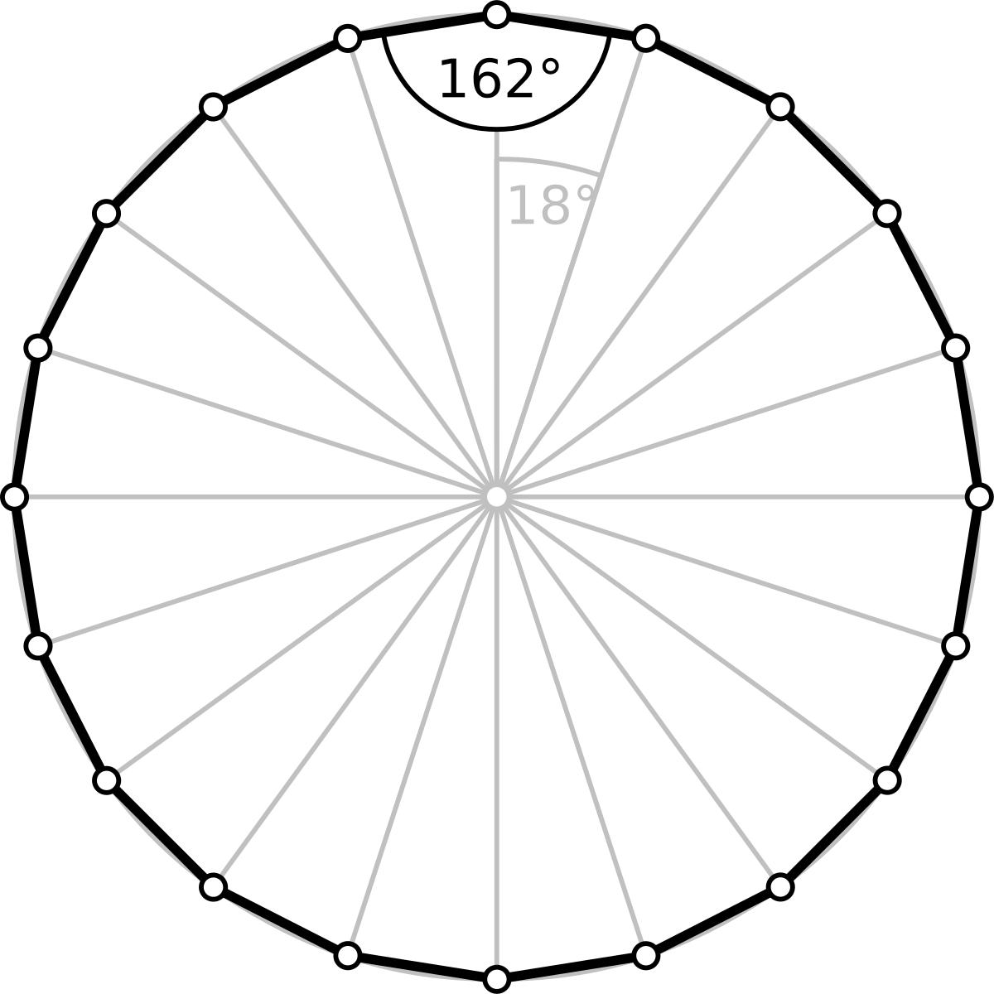

Constructing the Upper Decagonal Base
# Source: AI Source: Provided by: [Data Path: Persons Table -> ID Column: 1, Name_En Column: Motasem Essam] -> From: [ChatGPT] on [7/25/2026]
- Draw a second circle with a compass.
- Mark its center.
- Divide the circle into ten equal angular sections.
- Each central angle measures:
$$\frac{{360}^{°}}{10}={36}^{°}$$
- Mark the ten points around the circumference.
- Connect consecutive points using a ruler.
- Complete the regular decagon.
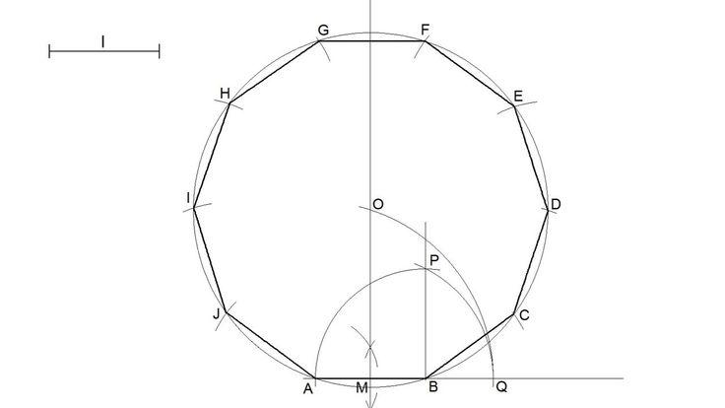

Positioning the Two Bases
# Source: AI Source: Provided by: [Data Path: Persons Table -> ID Column: 1, Name_En Column: Motasem Essam] -> From: [ChatGPT] on [7/25/2026]
- Draw the lower icosagon.
- Draw the upper decagon above the lower base.
- Keep both polygonal bases parallel.
- Position the upper base so its vertices and the lower base edges follow the intended alternating cupola arrangement.
- Maintain the intended ten-fold symmetry around the central axis.

Constructing the Triangular Faces
# Source: AI Source: Provided by: [Data Path: Persons Table -> ID Column: 1, Name_En Column: Motasem Essam] -> From: [ChatGPT] on [7/25/2026]
- Identify the ten corresponding triangular face positions.
- Connect the appropriate vertices of the upper and lower bases.
- Draw the edges that form ten triangular lateral faces.
- Check that each triangle shares its edges with the correct neighboring faces.

Constructing the Quadrilateral Faces
# Source: AI Source: Provided by: [Data Path: Persons Table -> ID Column: 1, Name_En Column: Motasem Essam] -> From: [ChatGPT] on [7/25/2026]
- Identify the ten positions between the triangular faces.
- Connect the remaining corresponding vertices and base-edge endpoints.
- Form ten quadrilateral lateral faces.
- Check that each quadrilateral joins the appropriate triangular faces and base edges.

Completing the Three-Dimensional Representation
# Source: AI Source: Provided by: [Data Path: Persons Table -> ID Column: 1, Name_En Column: Motasem Essam] -> From: [ChatGPT] on [7/25/2026]
- Review all lateral connections.
- Check that the upper and lower bases form one closed polyhedral surface with the lateral faces.
- Distinguish visible edges from hidden edges.
- Erase unnecessary construction lines.
- Add shading to distinguish the triangular and quadrilateral faces.

Key Points
# Source: AI Source: Provided by: [Data Path: Persons Table -> ID Column: 1, Name_En Column: Motasem Essam] -> From: [ChatGPT] on [7/25/2026]
- A Decagonal Cupola has a 10-sided upper base.
- Its lower base has 20 sides.
- It has 10 triangular lateral faces.
- It has 10 rectangular lateral faces.
- It has 22 faces in total.
- It has 50 edges.
- It has 30 vertices.
- Each upper vertex is shared by 4 faces.
- Each lower vertex is shared by 3 faces.
- It has tenfold rotational symmetry.
- It is a prismatoid.
- It is a member of the general N-gonal Cupola family.

Conclusion
# Source: AI Source: Provided by: [Data Path: Persons Table -> ID Column: 1, Name_En Column: Motasem Essam] -> From: [ChatGPT] on [7/25/2026]
The Decagonal Cupola is a prismatoid characterized by a decagonal upper base, an icosagonal lower base, and an alternating arrangement of 10 triangular and 10 rectangular lateral faces.
It extends the general cupola family to a ten-sided upper polygon and demonstrates how two different polygonal bases can be connected to create a complex three-dimensional geometric solid.
References and further study
- Wolfram MathWorld – Cupola
- EPFL – Cupola Geometry and Properties
- Cupolas – Geometric Models and Construction

